Assignment2

In this assignment, we will be exploring the basic operations of Image Segmentation

Hand in your write-up with necessary and relevant descriptions along with the Matlab code. Please submit a softcopy of the write-up during class on the due day, as well as a soft copy of the write-up and the codes to the course directory on Gmail ahmed.sultan94@yahoo.com before the due day.

Experiments with Image Segmentation.

Thresholding
- (lab) Computes a global threshold (level) that can be used to convert an intensity image to a binary image to noisy_fingerprint.
- Using Global threshold Algorithm
1. Select initial estimate
2. Segment the images using T into two groups G1 and G2 groups G1 and G2
3. Compute the averages of the two groups m1 and m2.
4. Computer a new threshold as T = (m1+m2)/2 5.
Repeat 2..4 until the difference between two successive thresholds is less than t.
- Otsu's method to minimize the intraclass variance of the black and white pixels use built-in function
- Assignment Save Results, Write your observation.. (b,c,d)
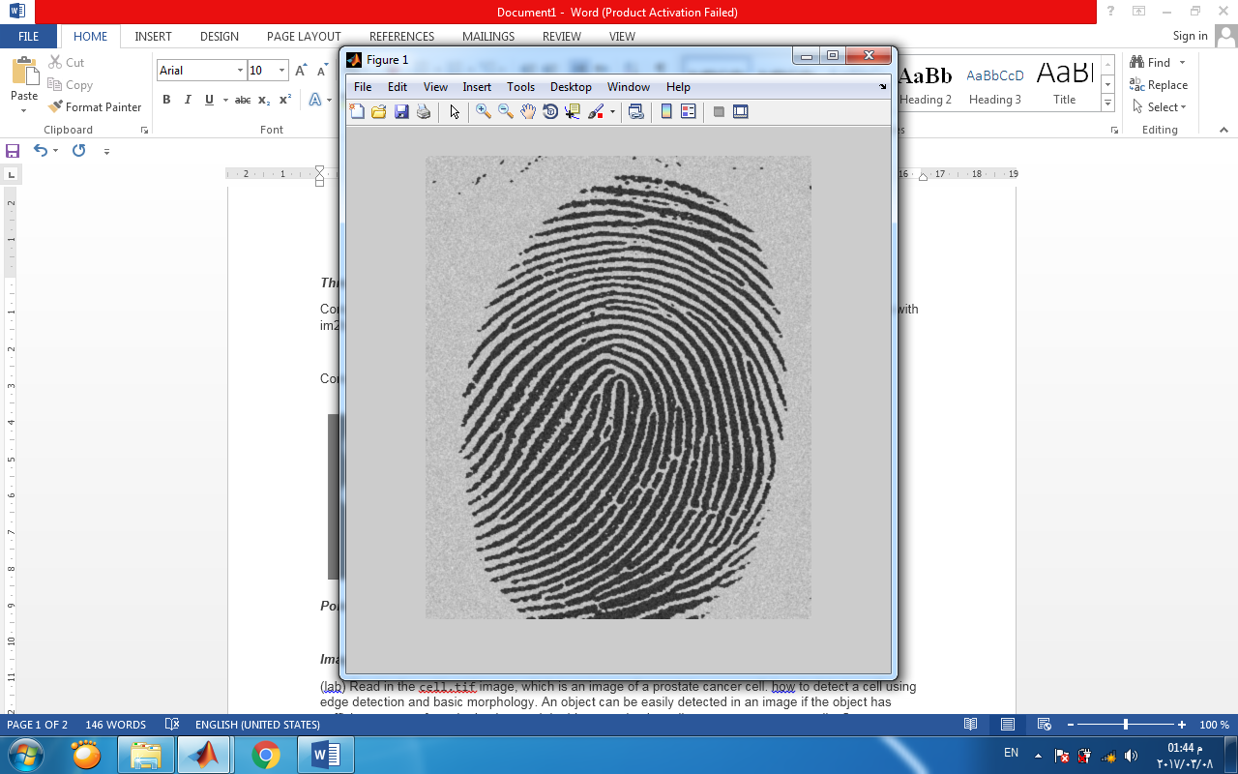(a) | (b)
(c) | (d)

- (lab) Compute multiple thresholds for an image circlesBrightDark.png using multithresh
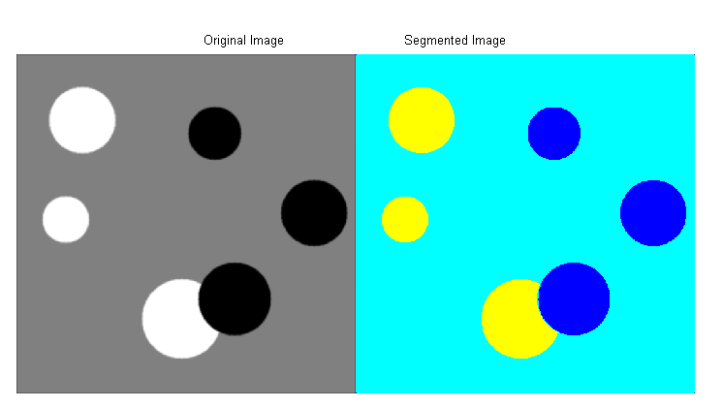
- Read noisy image, Filter image to remove noise the save noisy image after filtering, Compare Histogram of image before and after filter Image after filtering of Filtered image. Threshold noisy image, before filtering and save the results, write your observations
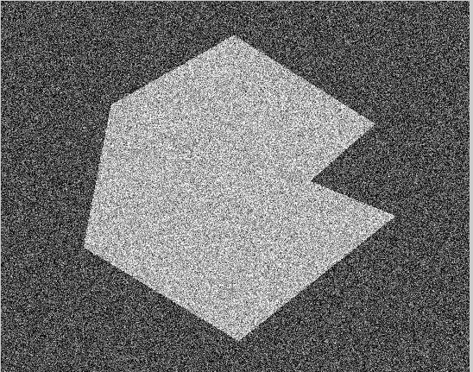
.

Point, Line, Edge
- Find edges in grayscale image using Sobel, Roberts, Prewitt to detect horizontal, vertical edges or both. Save results and write your observation

- Implement the Canny Edge Detector Algorithm ,Apply it on the following image” (headCT-Vandy.png”:
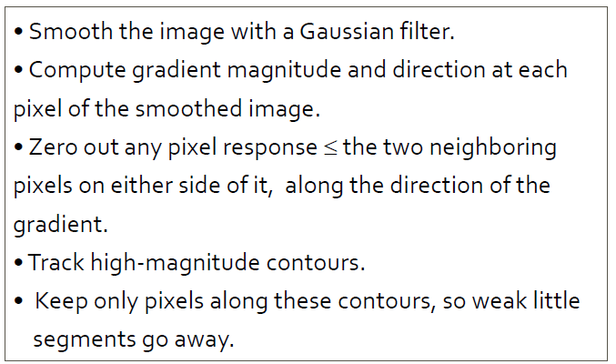
Image Segmentation
- Read in the cell.tif image, which is an image of a prostate cancer cell. how to detect a cell using edge detection and basic morphology. An object can be easily detected in an image if the object has sufficient contrast from the background. In this example, the cells are prostate cancer cells. Save output as segmented image, outlined original image
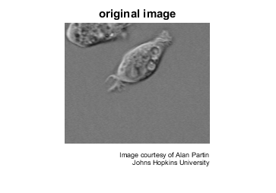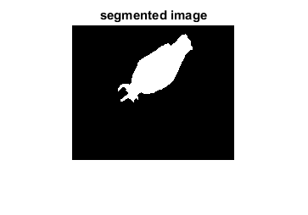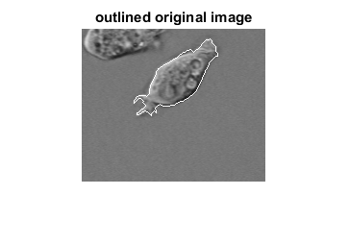
- (lab) Read in and threshold an intensity image. Display the labeled objects using the jet colormap, on a gray background, with region boundaries outlined in white.

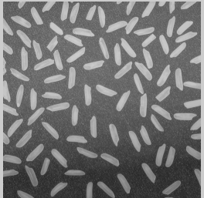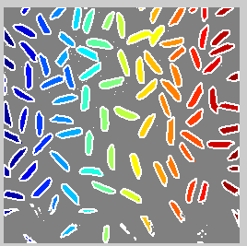
- (lab) Read blobs.png
  - Display object boundaries in red and hole boundaries in green.
  - Display parent boundaries in red (any empty row of the adjacency matrix belongs to a parent) and their holes in green.

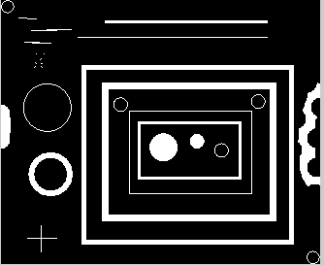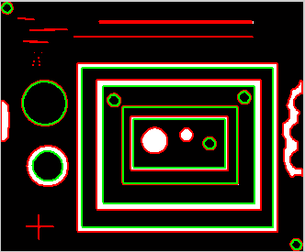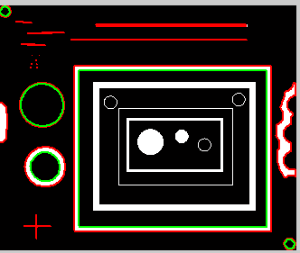
Orignal (a) (b)

